**Project Design Phase-II**

**Data Flow Diagram & User Stories**

|  |  |
| --- | --- |
| Date | 19 Oct 2023 |
| Project Name | Data Driven Insights on Olympic sports and Participation |

**Data Flow Diagrams:**

A Data Flow Diagram (DFD) is a traditional visual representation of the information flows within a system. A neat and clear DFD can depict the right amount of the system requirement graphically. It shows how data enters and leaves the system, what changes the information, and where data is stored.

**Data flow daigram:**

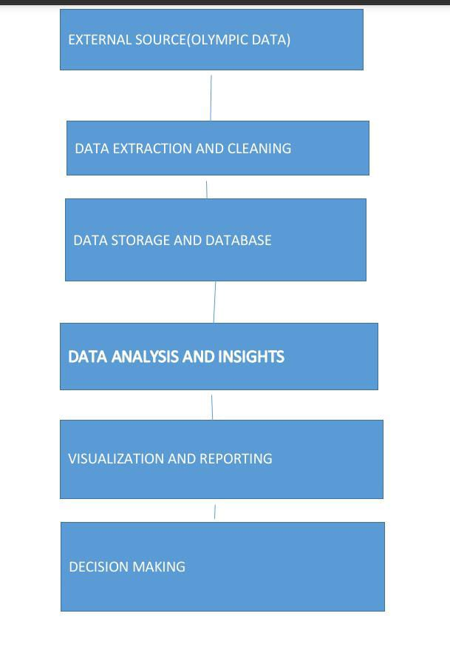

**User Stories**

Use the below template to list all the user stories for the product.

| **User Type** | **Functional Requirement (Epic)** | **User Story Number** | **User Story / Task** | **Acceptance criteria** | **Priority** | **Team Member** |
| --- | --- | --- | --- | --- | --- | --- |
| Data collection | Login | USN-1 | As a data analyst, I want to gather comprehensive data on Olympics sports, athletes, countries, and competitions, so that I can perform thorough analysis and generate valuable insights | The system should provide mechanisms to collect data from official Olympic records, sports federations, athlete profiles, and historical records. | High | Sharan R |
| Data cleaning |  | USN-2 | As a data analyst, I want to clean and preprocess the collected data to ensure its accuracy, consistency, and suitability for analysis. | Data variables should be standardized and formatted correctly to maintain consistency throughout the data set. | High | Abishek Vino R |
| Data analysis |  | USN-3 | As a data analyst, I want to analyze the collected data to identify performance patterns, trends, and correlations between different variables. | It should support the generation of charts, graphs, and maps to visualize the data and present insights effectively. | Medium | Nihal Shrivastav |
| Performance  analysis |  | USN-4 | As a data analyst, I want to develop predictive models to forecast outcomes such as medal counts, performance rankings, and the likelihood of participation in specific sports. | The system should support the development and implementation of predictive algorithms, such as regression models or machine learning algorithms. | Medium | Satish Kumar |
| Reporting |  | USN-5 | As a data analyst, I want to generate reports, summaries, and dashboards to communicate the insights and findings to stakeholders. | It should support the creation of interactive dashboards with drill-down capabilities to explore the data further. | High | Anand Kumar D |
| visualization | Dashboard |  |  |  |  |  |
|  |  |  |  |  |  |  |
|  |  |  |  |  |  |  |
|  |  |  |  |  |  |  |
|  |  |  |  |  |  |  |
|  |  |  |  |  |  |  |
|  |  |  |  |  |  |  |